Hi Fahad,

I hope you're doing well. Here are the instructions for a new partner, “Flora Black”. They are a holistic weight loss and addiction recovery center so we will be using some different copy for them. But, we can mimic the structure from the “Camelback Ketamine Integration” page. Here is their website for you to look at if we’d like to use some of the same “look and feel”, https://flora-black.com/.

I would like to build two landing pages for this partner. The first one will be a package page which will have 4 package offerings for clients to choose from. The second one will be an intake form that will be automatically sent to people’s email upon purchasing one of the packages. If you can please get the email and the campaign sequence set up in Keap, I can go in and write the copy before we make it live.

I've put instructions to you in < this kind of brackets >
—---------------------------

Co Branded logos at the top of the page
Their logo left and ours right ?

Then a banner from their website like this

<Replace> “Live a life of wellness & purpose ” with TRUE WELLNESS REQUIRES ONGOING SUPPORT <you can get rid of the get started button>

<Text in the white space that follows the banner>

At Flora Black, we know it takes community and ongoing support to live our best lives.

We’ve got you covered!

We’ve partnered with Being True To You, a first-of-its-kind Transformational Coaching company that’s offered people support through their transformational processes for more than 13 years. Your coach, and weekly group session, will help you find the extra connection, comradery, commitment and accountability you’ll need to achieve your goals with us.

<Fahad, you can follow this text with a product listing model the product listings after camelback template but please use Flora Blacks website colors The same dark blue for the text and icons and gold for the buttons if possible >

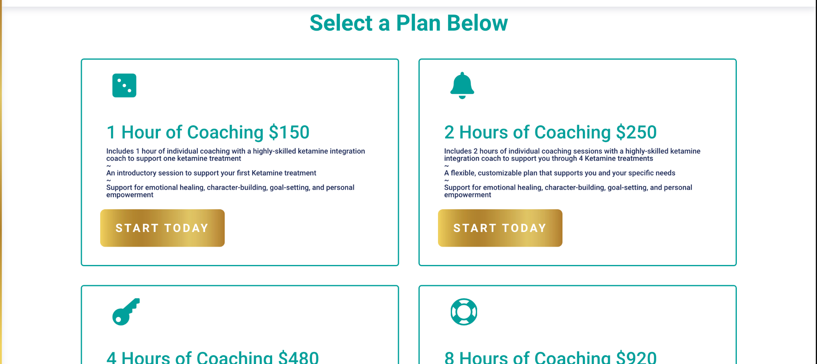

<Please replace> “Select a Plan Below” with “Select Your Level of Support”

For the plans, we will have four options:

4 Hours of Coaching $565 (this will only be available in a one-time payment)

8 Hours of Coaching $1,074 (this will have a two-month payment plan option for $537/month)
12 Hours of Coaching $1,539 (this will have a three-month payment plan option for $513)

24 Hours of Coaching $2,875 (this will haven a 6 month payment plan option for $480)

<Bullet points can be as follows>

1 Month of Coaching (4 hours of coaching but use 1 month as the heading)

Includes 4 hours of individual coaching with a highly-skilled transformational recovery coach and one month of weekly group coaching
~
A flexible, customizable plan that supports you and your specific needs. These 4 hours can be utilized as 1-hour, 30-minute, or 15-minute sessions.
~
Support for sticking with the plan and loving yourself through the process, emotional healing, character-building, goal-setting, and personal empowerment!

2 Months of Coaching and Support (8 hours of coaching but use 2 months as the heading)
Includes 8 hours of individual coaching with a highly-skilled transformational recovery coach and 2 months of weekly group coaching calls.
~
A flexible, customizable plan that supports you and your specific needs. These 8 hours can be utilized as 1-hour, 30-minute, or 15-minute sessions.
~
Support for sticking with the plan and loving yourself through the process, emotional healing, character-building, goal-setting, and personal empowerment!

3 Months of Coaching and Support (12 hours of coaching but use 3 months as the heading)

Includes 12 hours of individual coaching with a highly-skilled transformational recovery coach and 3 months of weekly group coaching calls.
~
A flexible, customizable plan that supports you and your specific needs. These 8 hours can be utilized as 1-hour, 30-minute, or 15-minute sessions.
~
Support for sticking with the plan and loving yourself through the process, emotional healing, character-building, goal-setting, and personal empowerment!

6 Months of Coaching and Support (24 hours of coaching but use 6 months as the heading)

Includes 24 hours - around 6 months of individual coaching with a highly-skilled transformational recovery coach and 6 months of weekly group coaching calls.
~
A flexible, customizable plan that supports you and your specific needs. These 8 hours can be utilized as 1-hour, 30-minute, or 15-minute sessions.
~
Support for sticking with the plan and loving yourself through the process, emotional healing, character-building, goal-setting, and personal empowerment!



<you can use this as the footer if it works, from their main page>

